***Dt : 17/9/2022***

***Diagram of Jagged Array:***

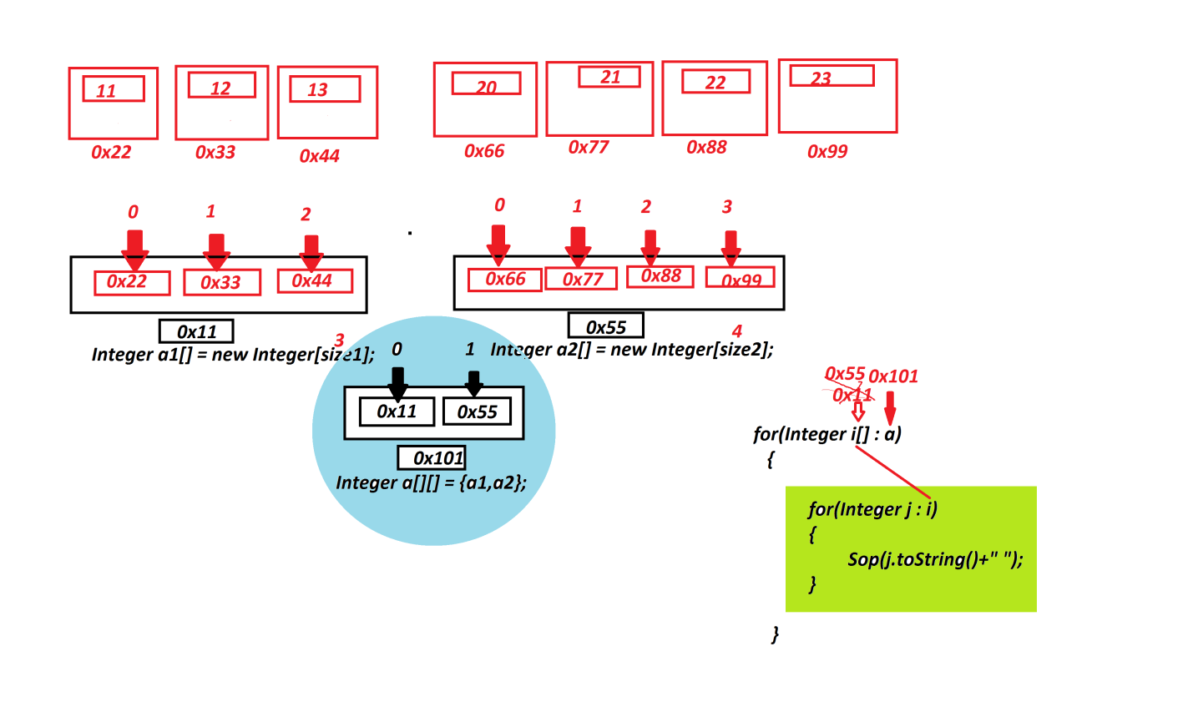

***============================================================***

***Summary of Arrays:***

***1.Array will hold WrapperClass objects***

***2.Array will hold String Objects***

***3.Array will hold Arrays(Jagged Array)***

***4.Array will Dis-Similer Objects(Object Array)***

***5.Array will hold User defined Class objects.***

***==========================================================***

***Dis-Advantage of Arrays:***

***=>Array size once defined cannot be modified at runtime or execution***

***time,because of this reason Arrays are not preferable to hold***

***dynamic data or runtime data.***

***Note:***

***=>In realtime Arrays are less used in application development.***

***=>In realtime Arrays are replaced by Collection<E> Framework.***

***===============================================================***

***\*imp***

***Communications in Java:(Relations in Java)***

***=>The process of establishing communications b/w components in***

***java are known as Communications in Java or Relations in Java.***

***=>Relations in Java are categorized into three types:***

***1.References***

***2.Inheritance***

***3.InnerClasses***

***1.References:***

***=>The process in which one object holding the reference of another***

***object is known as references concept,in this concept the members***

***of one object can use members of another object directly.***

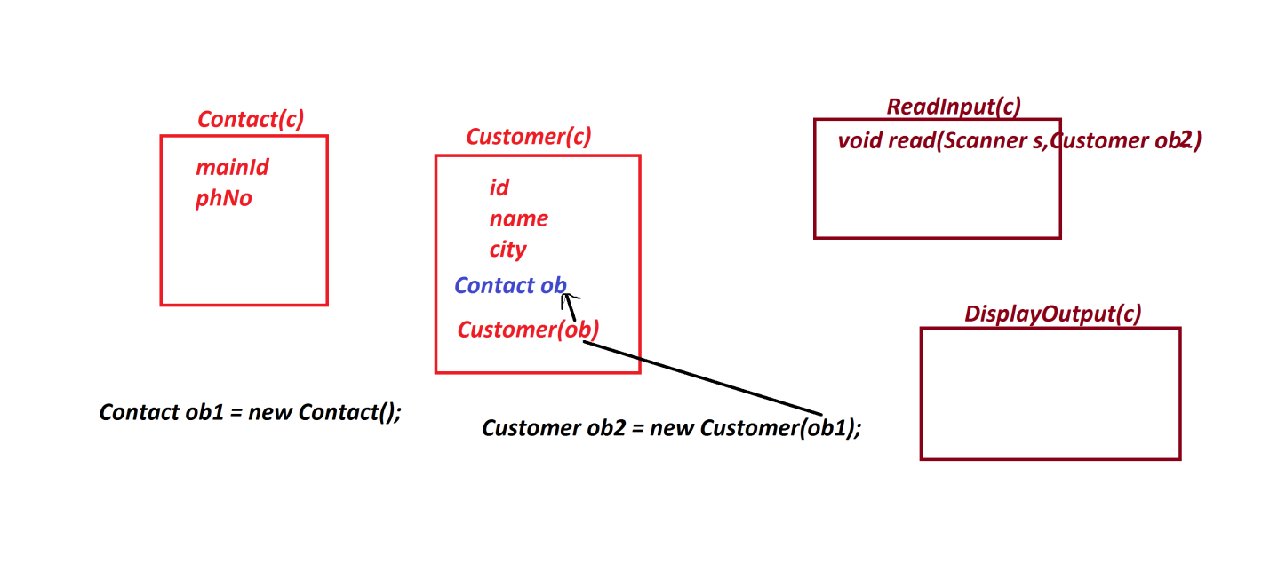

***Ex:***

***Contact.java***

***package test;***

***public class Contact {***

***public String mailId;***

***public long phNo;***

***}***

***Customer.java***

***package test;***

***public class Customer {***

***public String id,name,city;***

***public Contact ob;***

***public Customer(Contact ob) {***

***this.ob=ob;***

***}***

***}***

***ReadInput.java***

***package test;***

***import java.util.*;***

***public class ReadInput {***

***public void read(Scanner s,Customer ob2) {***

***System.out.println("Enter the CustId:");***

***ob2.id = s.nextLine();***

***System.out.println("Enter the CustName:");***

***ob2.name=s.nextLine();***

***System.out.println("Enter the CustCity:");***

***ob2.city=s.nextLine();***

***System.out.println("Enter the CustMailId:");***

***ob2.ob.mailId = s.nextLine();***

***System.out.println("Emter the CustPhNo:");***

***ob2.ob.phNo=s.nextLong();***

***}***

***}***

***DisplayOutput.java***

***package test;***

***public class DisplayOutput {***

***public void dis(Customer ob2) {***

***System.out.println("====CustomerDetails====");***

***System.out.println("CustId:"+ob2.id);***

***System.out.println("CustName:"+ob2.name);***

***System.out.println("CustCity:"+ob2.city);***

***System.out.println("CustMailId:"+ob2.ob.mailId);***

***System.out.println("CustPhNo:"+ob2.ob.phNo);***

***}***

***}***

***DemoRef1.java(MainClass)***

***package maccess;***

***import test.*;***

***import java.util.*;***

***public class DemoRef1 {***

***public static void main(String[] args) {***

***Contact ob1 = new Contact();***

***Customer ob2 = new Customer(ob1);***

***Scanner s = new Scanner(System.in);***

***ReadInput ri = new ReadInput();***

***ri.read(s, ob2);***

***DisplayOutput ro = new DisplayOutput();***

***ro.dis(ob2);***

***s.close();***

***}***

***}***

***o/p:***

***Enter the CustId:***

***A121***

***Enter the CustName:***

***Raj***

***Enter the CustCity:***

***Hyd***

***Enter the CustMailId:***

***r@gmail.com***

***Emter the CustPhNo:***

***989898123445***

***====CustomerDetails====***

***CustId:A121***

***CustName:Raj***

***CustCity:Hyd***

***CustMailId:r@gmail.com***

***CustPhNo:989898123445***

***========================================================***